**PRACTICAL 7 : Obstacle Detector**

**Aim :** To detect obstacles using an ultrasonic sensor and indicate the presence of objects.

**Overview :**

This project utilizes an ultrasonic sensor to detect obstacles and trigger an alert using LEDs or a buzzer. It demonstrates the application of distance measurement in real-time obstacle avoidance, a key concept in robotics and automation.

**Materials Required :**

* Arduino Uno R3
* 1 x 1 kΩ Resistor
* 1 x 250 kΩ Potentiometer
* 1 x 220 kΩ Resistor
* LCD 16x2
* Ultrasonic Distance Sensor (4-pin)
* Piezo
* Jumper Wires
* Arduino IDE (Installed on your Computer)

**Circuit Connection and Steps :**

1. **Ultrasonic Sensor (HC-SR04) : Connect VCC → 5V, GND → GND, Trig → D5 and Echo → D6.**
2. **Buzzer Connection: Connect Positive (+) → D7 and Negative (-) → GND.**
3. **Connect the 16x2 LCD Display to Arduino :**
   * RS → A5, E → A4
   * D4-D7 → D9, D8, D10, D11
   * VSS, RW, K → GND, VDD, A → 5V

**Circuit Diagram :**

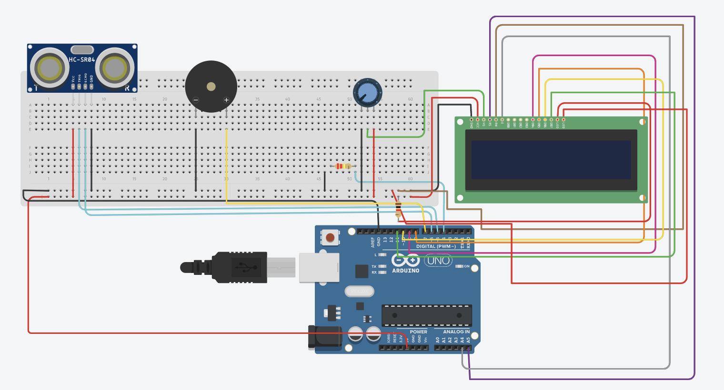

**Schematic Diagram :**

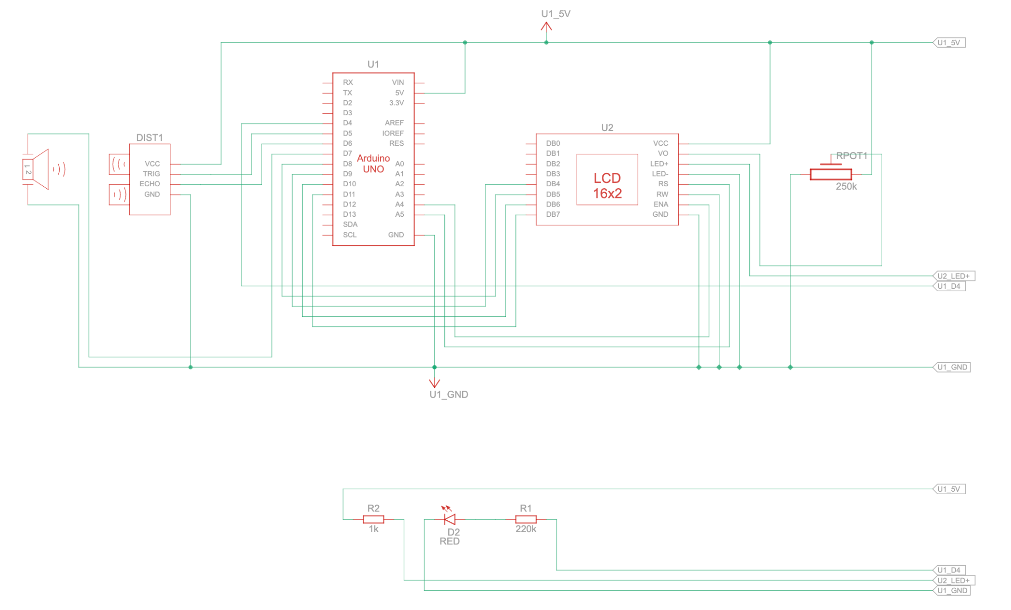

**Code :**

#include <LiquidCrystal.h>

// Pin Assignments

int redPin = 13, yellowPin = 12, greenPin = 11, buzzerPin = 7;

int echoPin = 6, triggerPin = 5;

int lcdRs = A5, lcdEn = A4, lcdD4 = 9, lcdD5 = 8, lcdD6 = 10, lcdD7 = 11;

LiquidCrystal lcd(lcdRs, lcdEn, lcdD4, lcdD5, lcdD6, lcdD7);

unsigned long lastTime = millis(), timeDelay = 100;

void setup() {

lcd.begin(16, 2);

Serial.begin(115200);

int pins[] = {redPin, yellowPin, greenPin, buzzerPin, triggerPin};

for (int i = 0; i < 5; i++) pinMode(pins[i], OUTPUT);

pinMode(echoPin, INPUT);

}

void loop() {

if (millis() - lastTime > timeDelay) {

lastTime = millis();

measureDistance();

}

}

void measureDistance() {

digitalWrite(triggerPin, LOW); delayMicroseconds(2);

digitalWrite(triggerPin, HIGH); delayMicroseconds(10);

digitalWrite(triggerPin, LOW);

double distance = pulseIn(echoPin, HIGH) / 58.0; // Convert to cm

lcd.setCursor(0, 0); lcd.print("Distance: " + String(distance, 1) + "cm ");

if (distance > 336 || distance <= 0) {

updateOutput(0, 0, 0, 0, "Out of Range");

return;

}

if (distance <= 20) updateOutput(450, 0, 0, 1, "Object: NEAR ");

else if (distance <= 100) updateOutput(400, 300, 200, 0, "Object: MID ");

else updateOutput(350, 500, 500, 0, "Object: FAR ");

}

void updateOutput(int freq, int beepOn, int beepOff, bool continuous, String message) {

lcd.setCursor(0, 1); lcd.print(message + " ");

digitalWrite(redPin, freq == 450);

digitalWrite(yellowPin, freq == 400);

digitalWrite(greenPin, freq == 350);

if (freq == 0) noTone(buzzerPin);

else if (continuous) tone(buzzerPin, freq);

else { tone(buzzerPin, freq); delay(beepOn); noTone(buzzerPin); delay(beepOff); }

}

**Results :**

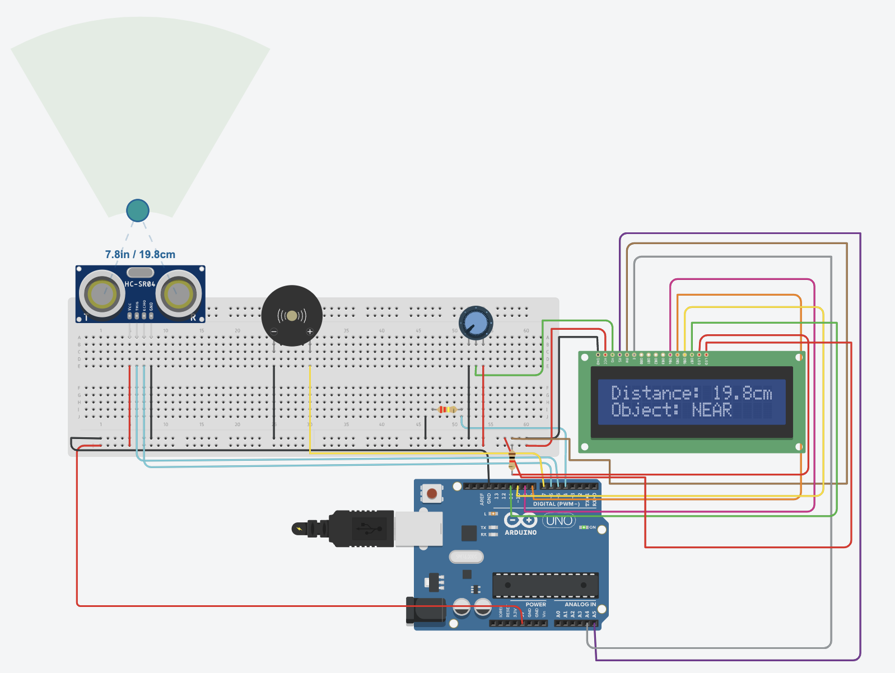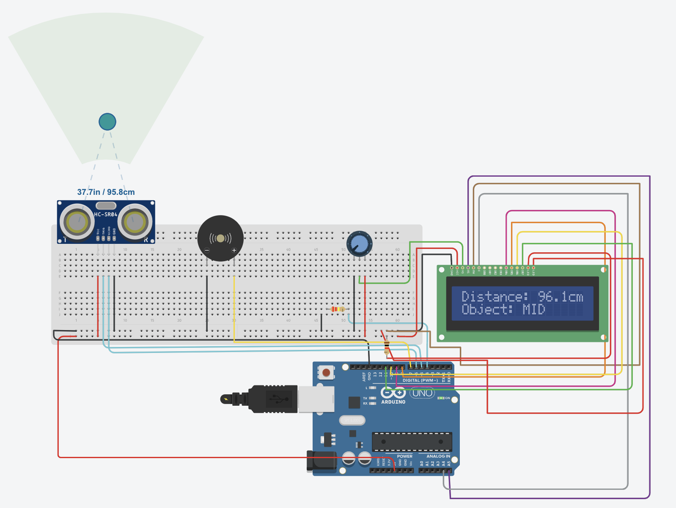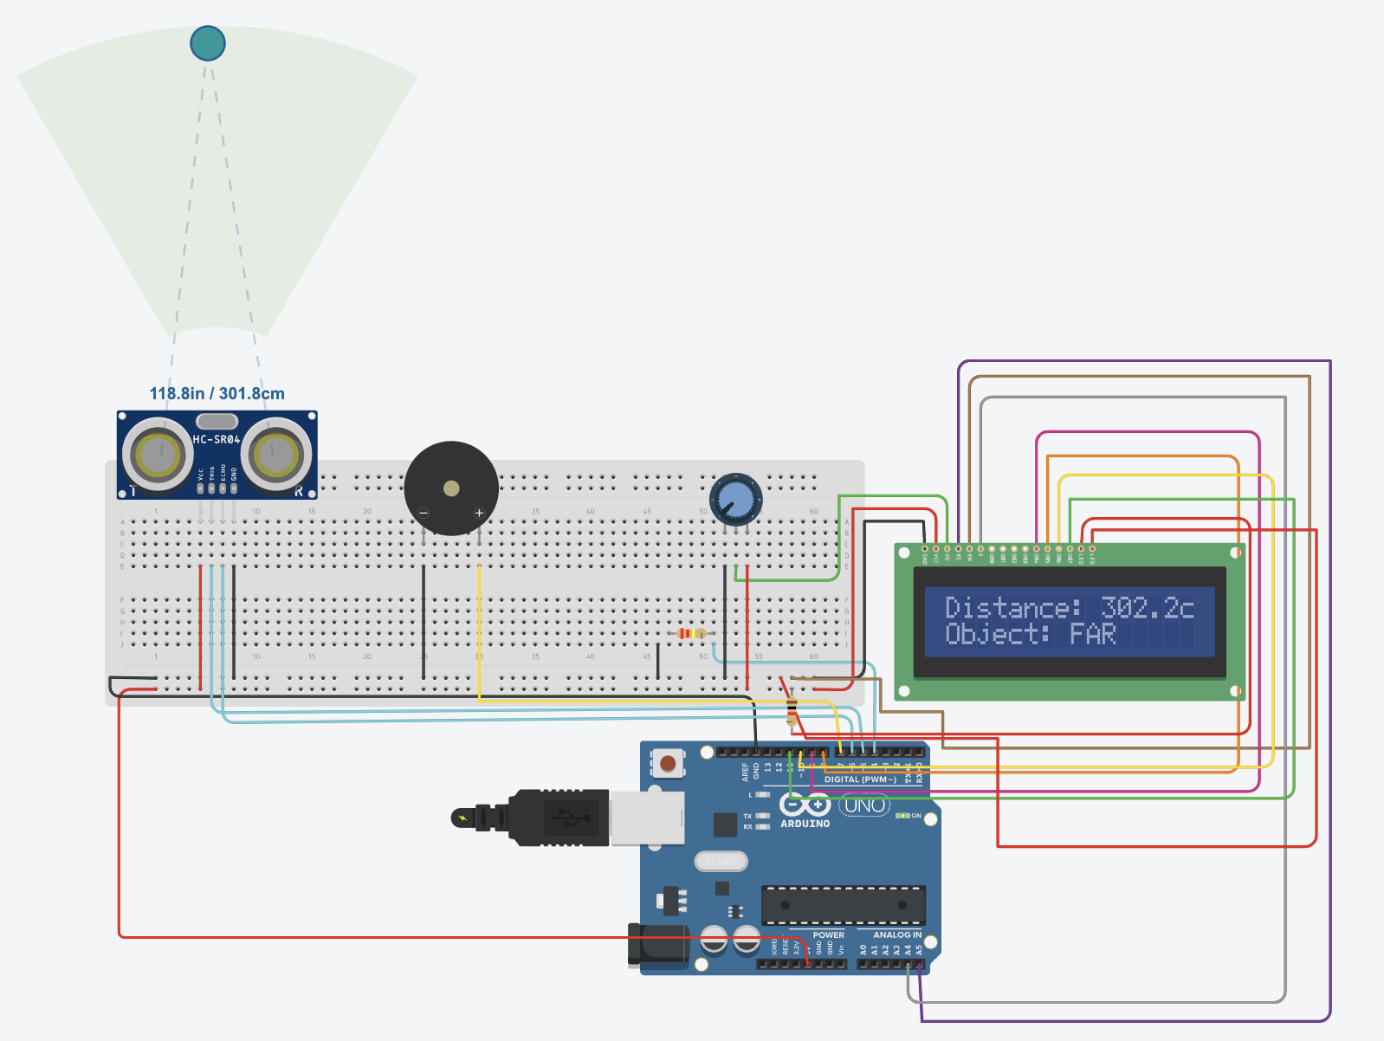

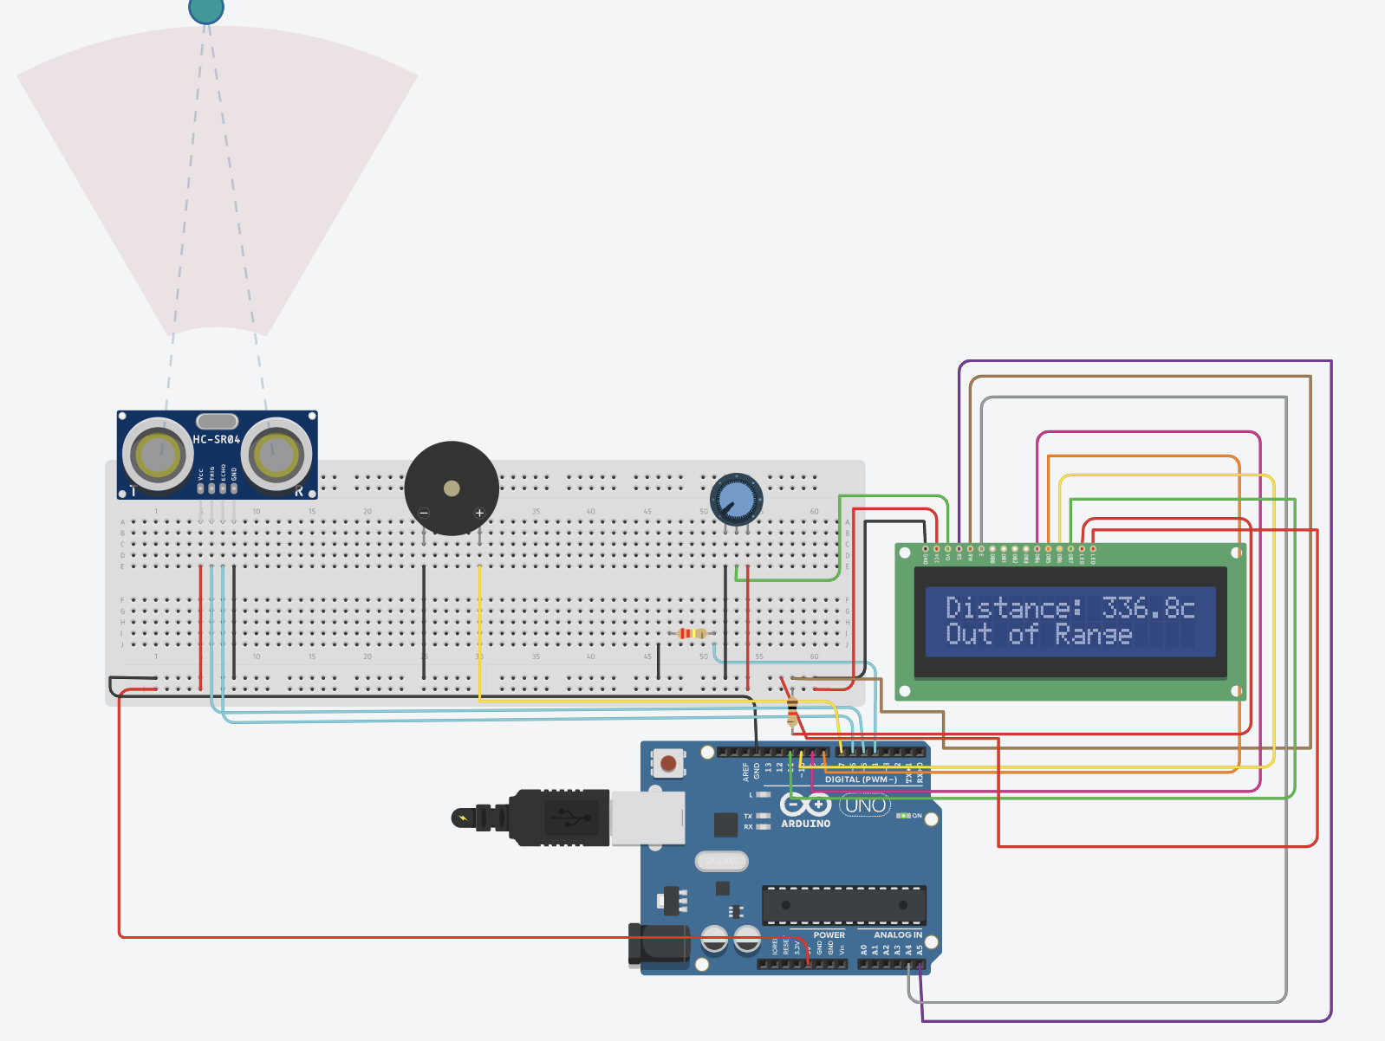

**Conclusion :**

The Obstacle Detector project successfully detects nearby objects using an ultrasonic sensor and triggers an alert system. It highlights the importance of real-time sensing in automation and robotics. This experiment serves as a foundation for applications like autonomous vehicles, security systems and smart navigation.